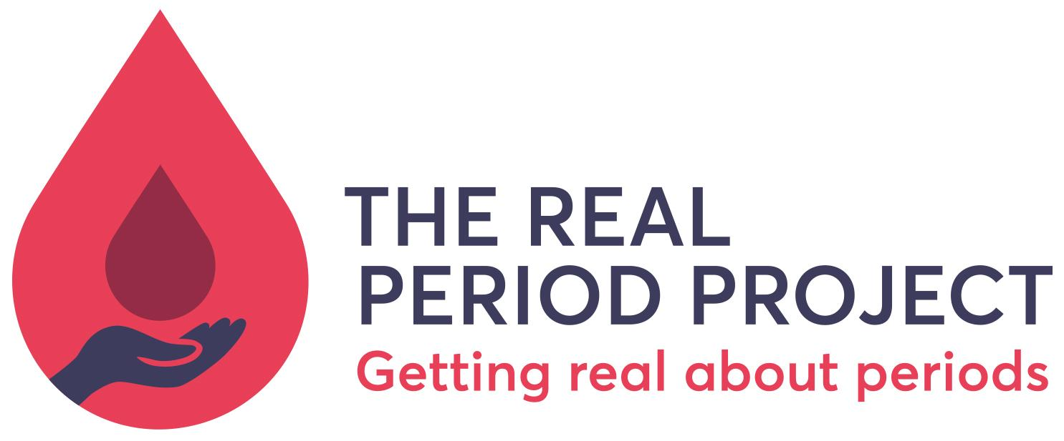

The Flow

Hi and thank you for your interest in contributing to this project!

The aim of The Flow is to build up a vibrant, diverse and interesting collection of menstrual stories and experiences, told first hand by people who experience periods.

We are looking for all kinds of stories - funny, thoughtful, outrageous, insightful, sad, all of it is welcome. We are called The Real Period Project because we wanted to explore real people’s real experience of periods. So if you’d like to add your voice and your story, we’d love to have you here!

Here are some guidelines to get you started:
- Videos can be up to 3 minutes long
- We would like this page to be available to everyone, so please avoid using swear words or talking about experiences not appropriate for a young audience (eg sex on your period stories - they would be great to include, but we don’t want to upset anyone with young children watching!)
- You can record your video on your computer, phone or a camera
- Send the file via WeTransfer or Dropbox to emily@realperiodproject.org and we will upload it to Youtube and from there will share on The Flow page on our website.
- Please start your video with your age (if you’re happy to divulge!) and the area where you live (just local city, country). You are welcome to share your name if you are over 18.
- Download, fill in and sign the Media Release form (found below) and email this along with the video file.If you are under 16 you’ll need to get a parent or guardian to sign it too please.

We would love to hear menstrual stories about:
- Periods and sport  - Periods in school/exams/uni  - Periods at work  - Periods and disability  - Periods as a parent  - Periods after pregnancy  - Non binary experience of periods  - Experiences with menstrual cycle charting | - Experience of religious/cultural practices around periods  - How your relationship with your periods has changed over your life  - First period experiences  - How your periods are changing in peri-menopause  - Anything else you would like to share!
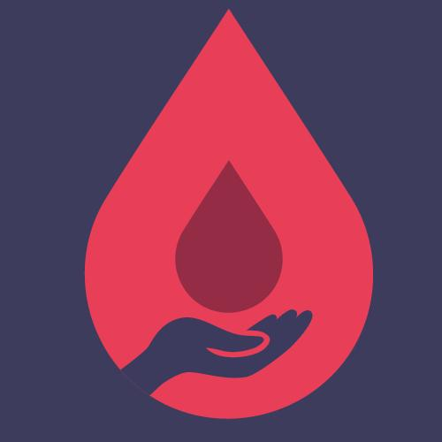 Real Period Project Media Release Form

The Real Period Project CIC (RPP) was founded in 2016. It is a social enterprise working to make high quality, empowering body positive and menstrual education available to everyone.

By signing this media release form, you are giving us permission to use photos, videos and audio recordings taken of you in the following ways:
· Publish on the RPP website
· Share on RPP social media channels
· Include in our presentations (may be shown to Local Authorities, other children and young people related organisations or in training sessions)
· Include in our publications and reports
· Include in our promotional materials, printed and online

We will never:
· Give any photos or videos to be used by third parties
· Misuse photos or videos
· Lie about you or any photos or videos you may be featured in
· Use the personal details or full names (which means first name and surname) of any young person in a photographic image, on video, on websites, in media interviews, in our organisation’s programme or in any of our other printed publications.
· Include personal e-mail, postal addresses, or telephone numbers on video, on our website, in our organisation’s programme or in any other printed publications.

You can remove your consent at any time and as of that date we will no longer use any images/video of you. However please note that existing printed publications will continue to be used until all supplies are finished. Outside media articles are widely available on the internet and as such we cannot guarantee to have all information removed from public access.

Please complete and sign the declaration overleaf. If you are under 16, please ask your parent or guardian to complete and sign the parent declaration. Thank you!

RECORDING TITLE: The Flow
DATE:

1) I, the undersigned, hereby authorise The Real Period Project CIC to use video content of me/my child that I have provided.
2) I authorise the use of any such electronic reproductions of me/my child for any purpose, including, but not limited to educational and other public media as may be deemed appropriate by The Real Period Project CIC (I understand that I/my child may be identifiable from such electronic reproduction)

AGREED AND ACCEPTED BY INDIVIDUAL

NAME:

SIGNATURE:

PHONE: EMAIL:
ADDRESS:

AGREED AND ACCEPTED BY PARENT / GUARDIAN (for individuals under 16 years of age)

I certify that I am the parent or guardian of the individual above. I hereby agree to assume legal responsibility for his/her authorisations referred to in this Media release form.

NAME:

SIGNATURE:

PHONE: EMAIL:
ADDRESS:

If you have any questions please contact Emily at The Real Period Project: call 07989 715128 or email emily@realperiodproject.org

